Sources: yogainternational.com
prenatalyogacenter.com
Yoga Poses For First Trimester:
1. Constructive Rest
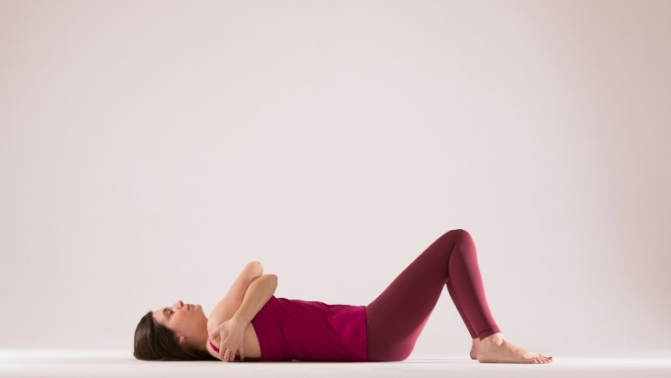
Steps:
1. Lie on your back with your knees bent and feet on the floor
2. Take your feet as wide as your mat, letting your knees knock together.
3. as you inhale your arms into a wide T shape
4. as you exhale, hug your arms across your chest with the right arm over
the left.
5. To switch sides, inhale your arms open into a T once again and on the exhale, cross with the opposite arm on top.
6. Remain for 20 breaths

2. Child’s Pose(Balasana)
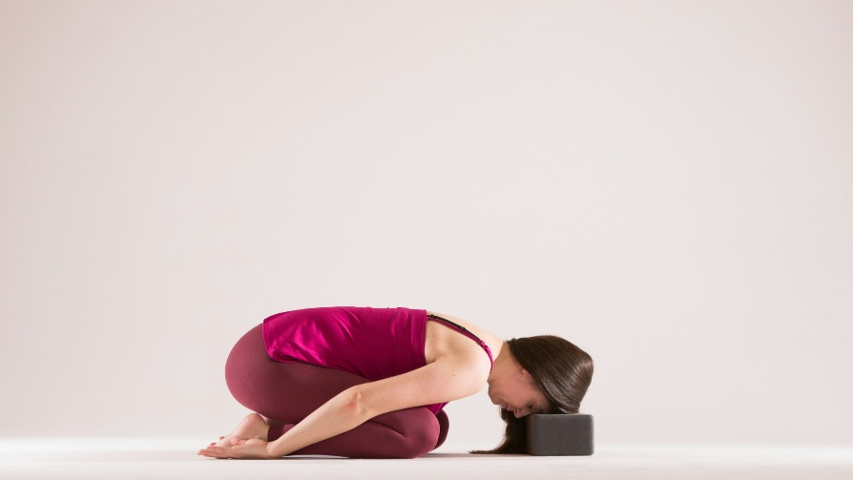
Steps:
- Come onto your knees, with your big toes together
- Place a pillow or rolled towel in front of you.
- Start with your knees hip width apart, but widen as you need to for comfort and to accommodate your growing baby
- Rest your forehead on the block.
3. Downward Facing Dog (Adho Mukha Svanasana)
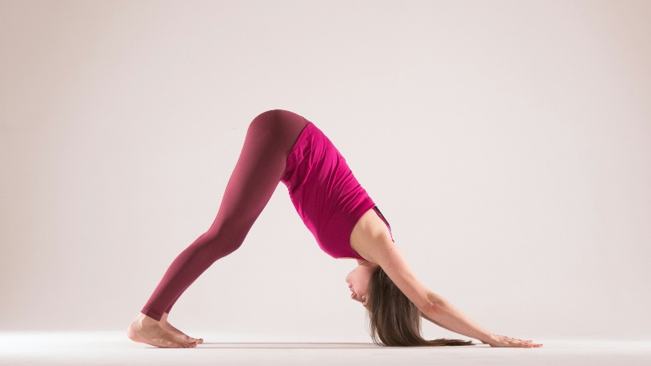
Steps:
- From hands and knees, place your hands slightly ahead of your shoulders.
- Curl your toes under, lift your knees off the floor.
- On an exhale, press your legs toward straight or keep your knees bent if your hamstrings feel tight, coming into downward facing dog.
- Stay for 10 breaths.

4. Side Angle Pose (Parsvakonasana)
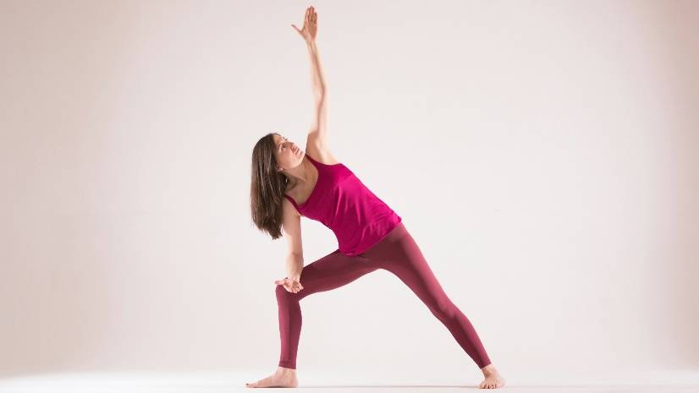
Steps:
- Stand with feet wide, turn your right foot out 90 degrees, and keep your back leg straight.
- Bend your right knee until it is stacked directly over your ankle in a deep lunge.
- Rest your right forearm on your thigh or place your hand on the floor beside your foot.
- Reach your left arm over your ear to create a straight line from your heel to your fingertips.
- Turn your chest toward the ceiling and gaze upward while keeping your back foot grounded.
- Stay for 15 full, deep breaths.

5. Goddess Pose (Utkata Konasana)
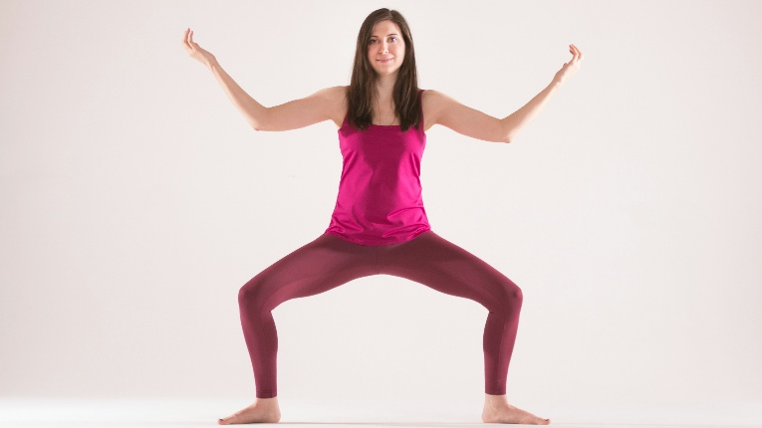
Steps:
- Stand with your feet about 3–4 feet apart and turn your toes out at a 45-degree angle.
- Exhale as you bend your knees deeply, aiming to get your thighs parallel to the floor.
- Keep your knees stacked directly over your ankles and prevent them from collapsing inward.
- Raise your arms to shoulder height and bend your elbows at 90 degrees with palms facing forward.
- Tuck your tailbone slightly and keep your spine vertical while gazing straight ahead.
- Stay for 10 breaths.

Yoga Poses for 2nd trimester:
1. Tree Pose (Vrksasana)
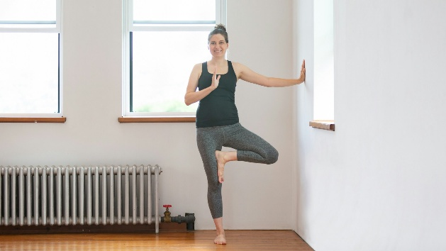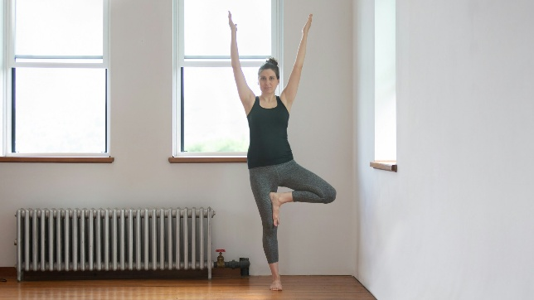
Steps:
- Bend your left knee and turn your left leg out, placing your left foot above or below your right knee.
- Bring your hands into prayer.
- When Balanced, try reaching both arms overhead with the arms separated at shoulder-width.
- Remain for 10 full breaths the switch sides.
2. Side Plank (Vasisthasana)
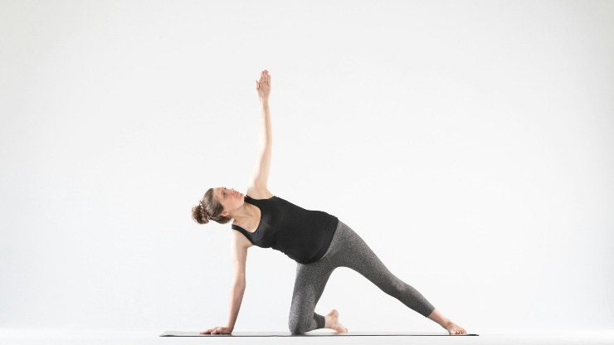
Steps:
- Start on all fours and extend your right leg straight out to the side, pressing your foot flat.
- Place your left hand firmly on the mat directly under your shoulder for support.
- Reach your right arm straight up toward the ceiling, keeping it in line with your bottom arm.
- Turn your chest open to the side and look up at your top hand while keeping your core engaged.
- Remain in the pose for 10 full breaths.

3. Supported Fish (Matsyasana)
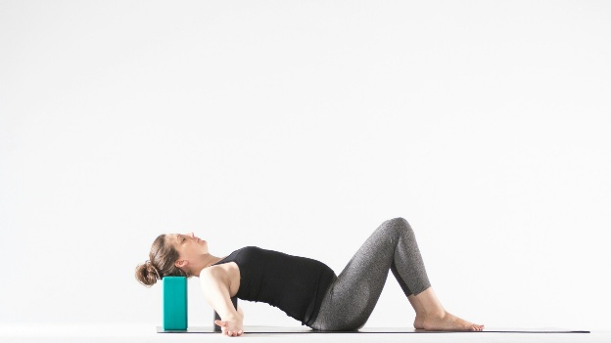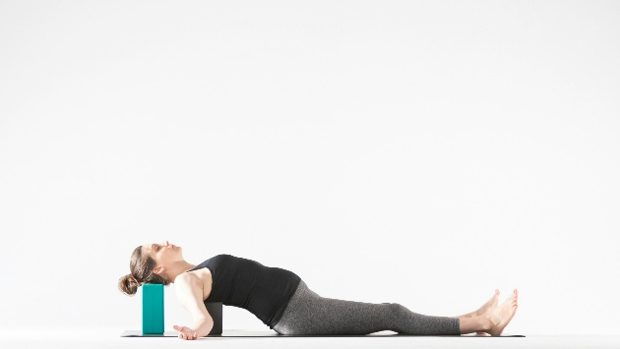
Steps:
- Place one yoga block horizontally where your shoulder blades will rest and a second block (at the same or higher level) where your head will rest.
- Sit in front of the blocks with your back to them and slowly lower yourself until your mid-back is supported by the first block.
- Rest your head comfortably on the second block, adjusting it to support the natural curve of your neck.
- Once you are comfortable, remain in the pose for 25 long breaths.
- Extend your legs straight out or bend your knees with feet flat on the floor if you have a sensitive lower back.
- Relax your arms out to the sides with palms facing up, allowing your shoulders to drape toward the floor to fully open your chest.

4. Wide Straddle (Upavistha Konasana)
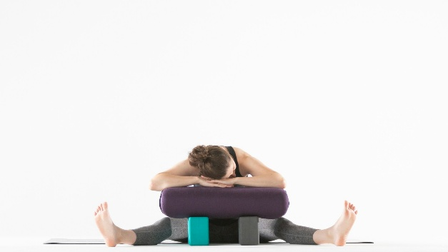
Steps:
- Begin seated with both legs straight out in front of you.
- Separate your legs about three to four feet apart.
- Place two blocks on the medium setting just shy of the width of the bolster and stack the bolster on top of them, creating a pillow for your head.
- Fold forward and rest your forearms on the bolster, turning your head to one side.
- Remain in the pose for 30 breaths, turning your head in the opposite direction halfway through.

5. Warrior Pose(Virabhadrasana)
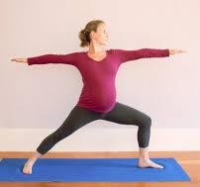
Steps:
- Stand with feet wide and turn your right foot out 90 degrees while keeping your left foot slightly angled in.
- Bend your right knee until it is stacked directly over your ankle and parallel to the floor.
- Extend both arms out to the sides at shoulder height, keeping them parallel to the ground with palms facing down.
- Keep your torso upright and turn your head to gaze out over your right fingertips.
- Remain for 10 breaths.

Yoga Poses for 3rd Trimester:
1. Easy Pose (Sukhasana) With Arm Strengthening and Wrist Rolls
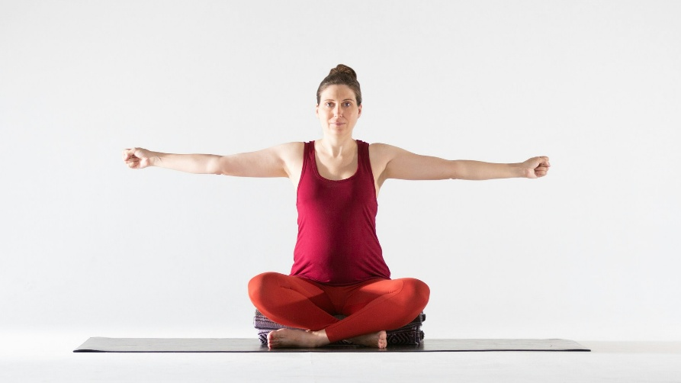
Steps:
- Begin by sitting on a blanket with legs crossed and your right shin in front of your left.
- Reach your arms out to the sides at shoulder height and make fists.
- For 10 breaths make small circles with your wrists in one direction, and then the other (five breaths each side).
- Your arms will be up for a total of 20 breaths per side.

2. Wide Chair Pose (Utkatasana)
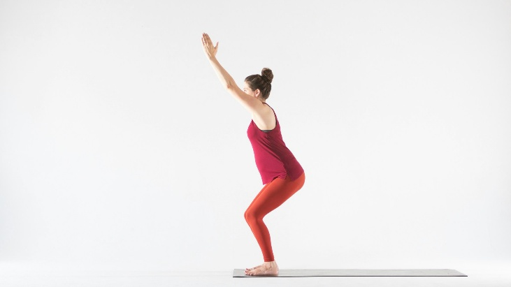
Steps:
- Stand with your feet together or hip-width apart and reach your arms straight up toward the ceiling.
- Exhale as you bend your knees and shift your hips back as if you are sitting into an invisible chair.
- Keep your weight in your heels and ensure your knees do not extend past your toes.
- Lift your chest upward while keeping your tailbone tucked slightly to maintain a long spine.
- Try to stay for 25 breaths.

3. Dynamic Goddess Pose (Utkata Konasana) With a Hold
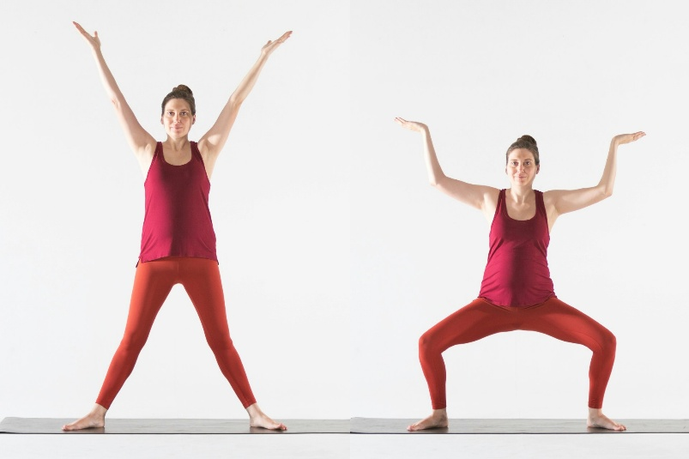
Steps:
- Stand with your feet about three feet apart and turn your toes out at a 45-degree angle.
- Exhale as you bend your knees deeply, keeping them aligned directly over your ankles.
- Lower your hips until your thighs are as close to parallel with the floor as possible.
- Raise your arms and bend your elbows at 90-degree angles with palms facing inward or forward.
- Keep your back straight and your chest lifted while holding the pose.
- Repeat five times. After the fifth breath, hold the squat for 10 full breaths.
4. Tabletop on Forearms With Hammock Rocks
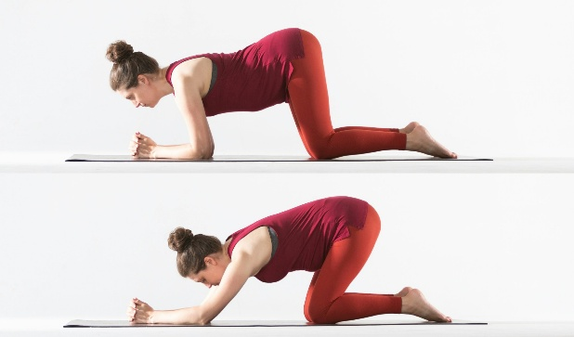
Steps:
- Start in a tabletop position on your hands and knees with your hips stacked directly over your knees.
- Begin to shift your body forward on an inhale.
- Shift back on an exhale, rocking your baby with the breath.
- Rock for 20 breaths.
5. Upper Back Opener With Elbows on a Chair
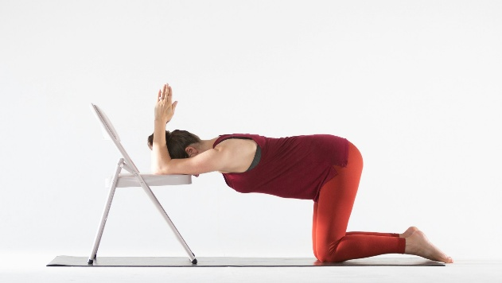
Steps:
- Kneel in front of a chair with your hips over your knees and legs and feet hip-width apart.
- Place your elbows on the chair and bend them so that your forearms are perpendicular with the chair seat and your fingertips point up.
- Lower your head in between your arms.
- Move your chest toward the ground.
- Remain in the pose for 20 breaths.

